Will & Cady – Salvage

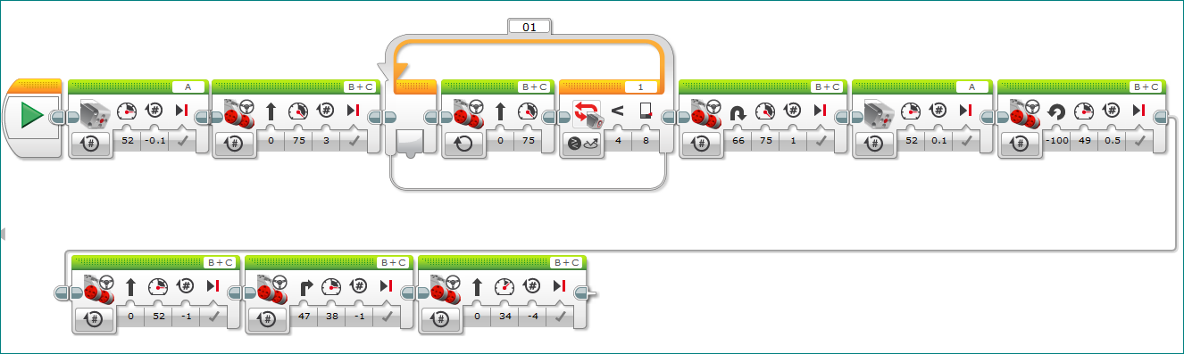

Will & Cady – Factory

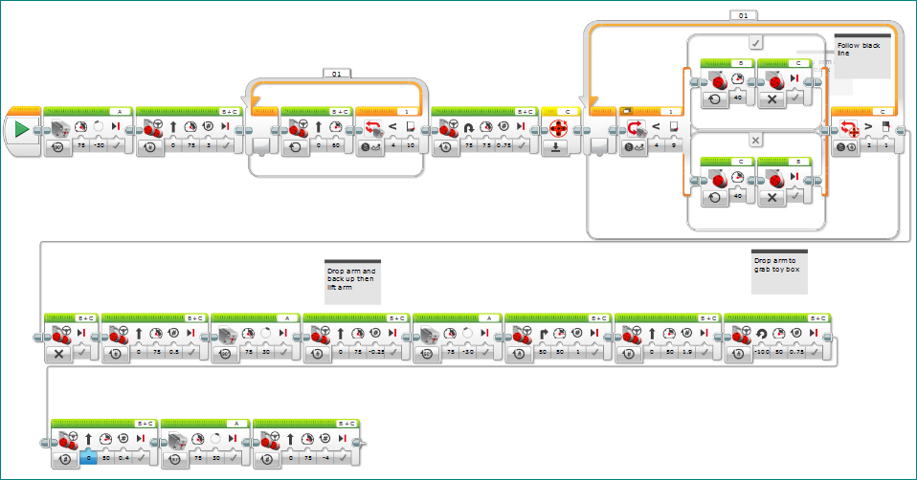

Robbie & Evan - Turtle

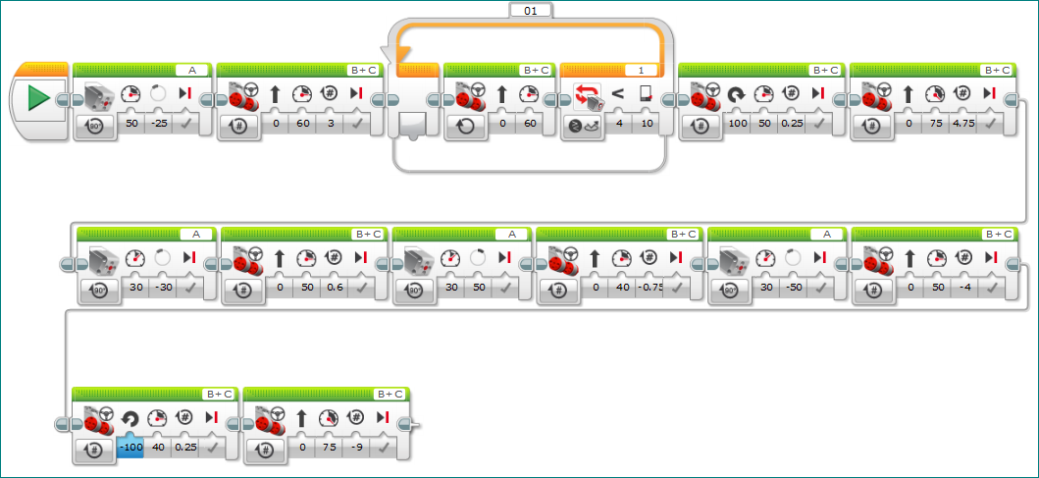

Robbie & Evan – Rebuild Car

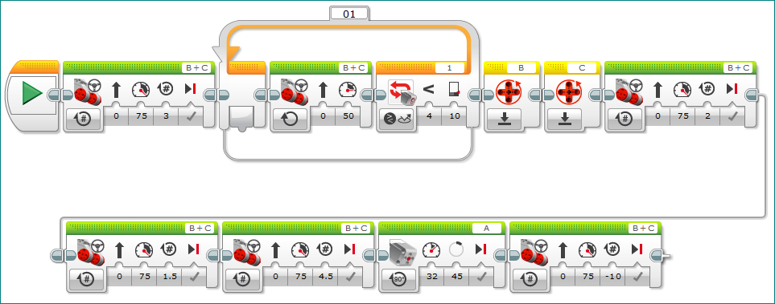

Chris & Josh – Methane

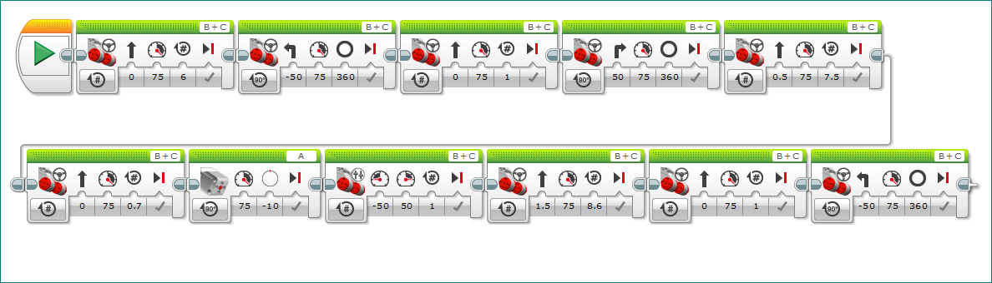

Chris & Josh – Transport



Zach & Jackson – Clear Sorter Jam & Careers

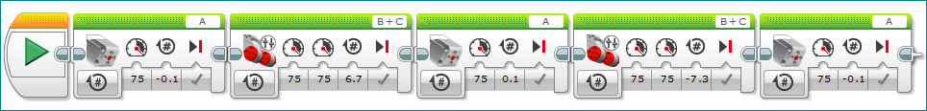

Zach & Jackson – Run Sorter

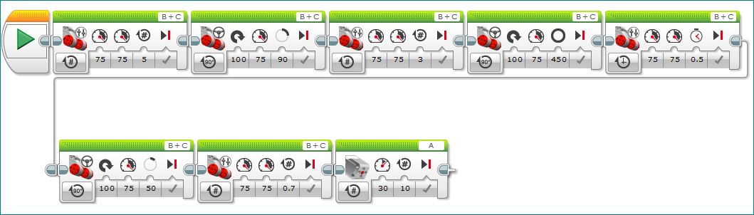

Bryce – Octopus & Chicken & Composter

